**Exercise 2**

**Question:**

Given a time in 12-hour AM/PM format, convert it to military (24-hour) time. Note: Midnight is 12:00:00AM on a 12-hour clock, and 00:00:00 on a 24-hour clock. Noon is 12:00:00PM on a 12-hour clock, and 12:00:00 on a 24-hour clock. Function Description Complete the timeConversion function in the editor below. It should return a new string representing the input time in 24 hour format. timeConversion has the following parameter(s): ● s : a string representing time in 12 hour format Input Format A single string s containing a time in 12-hour clock format (i.e.hh:mm:ssAM or hh:mm:ssPM), where 01 <= hh <= 12 <= 00 and 00 <= mm, ss <= 59. Constraints ● All input times are valid Output Format Convert and print the given time in 24-hour format, where 00 <= hh <= 23 Sample Input 0 07:05:45PM Sample Output 0 19:05:45

**Solution Code:**

|  |
| --- |
| using System;  using System.Collections.Generic;  using System.IO;  using System.Linq;  class excercise2  {    static void timeConversion (string s)  {    DateTime d = DateTime.Parse (s);    Console.WriteLine ("Format 12 Jam:");    Console.WriteLine ("07:05:45 pm");    Console.WriteLine ("Format 24 Jam:");    Console.WriteLine (d.ToString ("HH:mm:ss"));    Console.ReadLine ();    }  static void Main (string[]args)  {    string s = "07:05:45 pm";    timeConversion (s);  }  } |

**Result:**

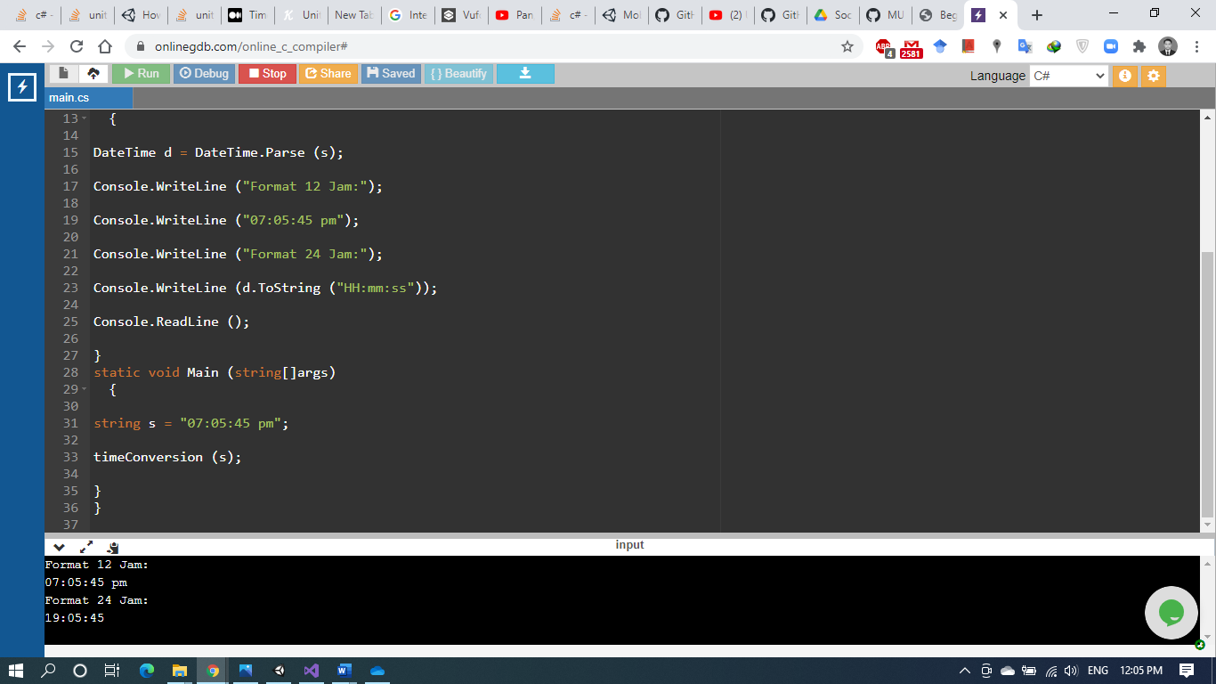

**Another Result:**

